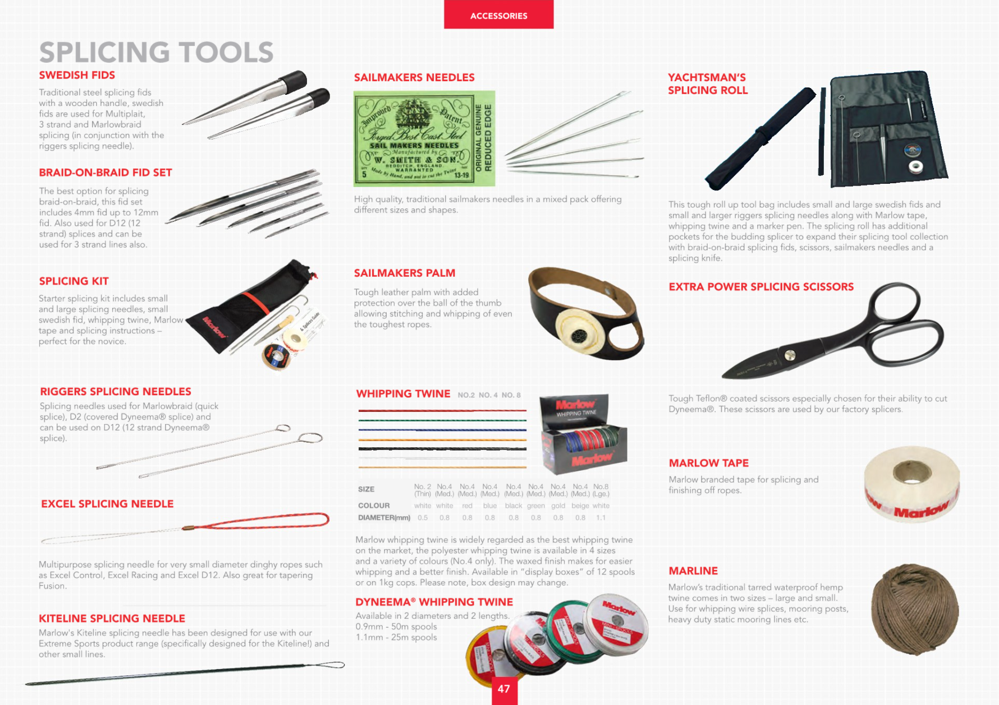
ACCESSORIES |  |  | Page 47
DESCRIPTION |  |  | RRP (€)
RIGGERS SWEDISH FID SMALL |  |  | 11.76
RIGGERS SWEDISH FID LARGE |  |  | 21.58
BRAID-ON-BRAID FID SET |  |  | 96.48
SPLICING KIT |  |  | 65.79
RIGGERS SPLICING NEEDLE SML |  |  | 10.79
RIGGERS SPLICING NEEDLELRG |  |  | 13.68
NEEDLES MIXED PACK |  |  | 21.13
SAILMAKERS PALM |  |  | 13.46
DYNEEMA WHIPPING TWINE |  |  | 34.93
YACHTSMANS SPLICING ROLL |  |  | 116.62
SCISSORS EXTRA POWER TEFLON |  |  | 140.28
MARLOW TAPE |  |  | 4.68
MARLINE 302 1X250g SPOOL |  |  | 21.21
HOT KNIFE WITH BOX & BLADE |  |  | 176.18
HOT KNIFE BLADES |  |  | 26.77

